Anexa 1
la Nota privind crearea rețelei de resurse educaționale deschise

Fișă de identificare RED

Nume/prenume autor: KOVÁCS-GORBOI KATALIN- MELINDA
Denumirea resursei educaționale propuse: Love and Marriage
Tema/scurta descriere: acest plan de lecție a fost conceput pentru a fi inclus în cadrul unității de învățare People Power, folosind manualul Upstream Advanced, clasa a XI-a. Conținuturile incluse au fost gândite pentru a acoperi două ore. În aceste două ore, prin diverse activități, se parcurge cronologic diferitele faze ale unei relații. Sunt incluse activități individuale, în perechi, grupe, elevii având ocazia să-și exerseze toate capacitățile lingvistice.
Scopul materialului propus:
- didactic (de utilizat la clasă/cu elevii
- pentru elev (de utilizat de către elevi)
- de documentare pentru cadre didactice
- altele ………………………………….
Nivel de învățământ /clasa: liceu
Aria curriculară/disciplina: LIMBA ENGLEZĂ
Material extracurricular:-
Competențe vizate: - să-și exprime opinii
- să argumenteze punctul lor de vedere
- să extragă informații relevante dintr-un material citit și unul audiat pentru a rezolva diferite sarcini de lucru, .

Lesson plan
School: ”Petru Maior” Tehnological High School, Reghin
Name: Kovacs- Gorboi K. Melinda
Class: 11th B Level: Advanced Date: 13th and 14th February 2020
Textbook: Upstream Advanced, Express Publishing
Lesson: Love and Marriage (Unit: People Power) - 2-hour activity
Skills involved: all skills
Type of lesson: practice - practicing of skills
Source: textbook, www.onestopenglish.com, 700 Classroom Activities, www.busyteacher.org
Class organization: T-S, IW, PW
Objectives:1. To introduce the topic to the students
2. To read, write and speak about the period before marriage
3. to practice speaking skills and some structures through a wedding role play
4. scan texts for information, to summarize and compare texts
5. to discuss, read about and listen about successful marriage
6. to role play a married couple
Materials: word cards, worksheets, cards with questions, speakers, text for reading

Contents:
Objective 1: - context: introducing the topic and creating pairs - Warm up
-activity: the teacher prepares 8 papers with words/phrases on them and invites 8 students to pick them from her desk and show them to the class. The class should guess that after discussing other relationships during this unit, today they will talk about marriage. Then the rest of the students choose another card with definitions that match the word cards and thus some pairs are created.
- Each student receives a piece of paper with a question on it, e.g. At what age do you want to get married? and answer each other’s questions in pairs.
Objective 2: - context: discussing the pre- marriage state
-activity: - T writes the title MARRIAGE on the blackboard. Then she explains that they are going to take a journey that starts with dating and ends with marriage. As a first step Ss come up with ideas about the reasons for dating. Then they do ex. 3a/56 from the textbook, individually, to choose the important characteristics of a future husband, write them in their copybooks and a few students report back to the class.
- after dating the next logical step is looking for a future husband or wife. T gives a short, funny text to the students about a store where husbands can be bought, they read it and in pairs they will come up with an ending. Then they compare it with the ending the T presents.
- continuing the journey, they have found the perfect partner and are preparing for the wedding. They will work with the same partner again and will agree the terms of a marriage contract.
Objective 3: - context: speaking at a wedding reception
-activity: T explains that they will participate at a wedding reception. Students receive a role card and will act according to those roles. The T puts some papers on the blackboard which present some ways of making small talk, gossiping and reacting to gossip. Ss read their role cards, stand up, imagine being at a wedding, mingle and talk to the other students.
Objective 4: - context: to compare different weddings –reading
-activity: pairs of students receive a page with 6 short texts on it. They read the text, then try to fill in the gaps with the name of the country the speakers are from and put down in their notebooks 1 idea about each wedding. Some students tell the class what they liked or disliked about the weddings described.
Objective 5: - context: to discuss the success of a marriage
-activities: - T writes Successful marriage on the board and invites students to share their ideas about it.
- Then the pairs receive a table which contains 4 pieces of funny advice froma married man. They have to match the parts of sentences from the different columns.
- To hear another opinion they listen to Frank Sinatra’s 1965 version of Love and Marriage. Students are asked to agree or disagree with the opinion presented in the song.
Objective 6: - context: to role play a married couple – speaking
-activity: the pairs of students are going to pretend to be a married couple. They are given about 5 minutes to discuss and agree on details about their life. Then a quiz follows when the teacher asks them questions, and both of them answer them on paper. They compare their answers and the couple with the most points is the winner.

MATERIALS:
- Words to create pairs: RINGS, WEDDING, BUY A HOUSE, IN-LAWS, HAVE CHILDREN, MONOGAMY, SPOUSE, LOVE
- Definition of words:
A relative by marriage, and especially the mother or father of a person's husband or wife.
The symbol of marriage worn by the husband and wife on their fingers
A ceremony to perform and celebrate the marriage
This is necessary for the new couple to make living together possible
The next generation that completes the family
To have only one husband or wife
A more official name for husband or wife
A pleasant feeling that leads to marriage
- Questions for warm up

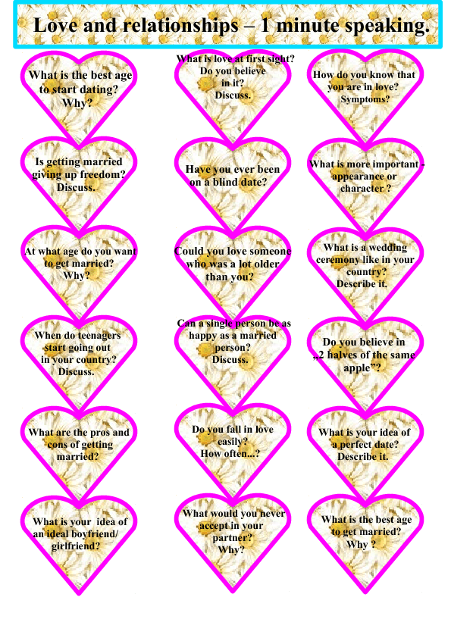
- Reading
THE HUSBAND STORE
A store that sells new husbands has just opened in New York City, where a woman may go to choose a husband. Among the instructions at the entrance is a description of how the store operates.
You may visit the store ONLY ONCE! There are six floors and the attributes of the men increase as the shopper ascends the flights. There is, however, a catch: you may choose any man from a particular floor, or you may choose to go up a floor, but you cannot go back down except to exit the building!
So, a woman goes to the Husband Store to find a husband... On each floor the signs on the doors read:
Floor 1 - These men have jobs.
Floor 2 - These men have jobs and love kids.
Floor 3 - These men have jobs, love kids, and are extremely good looking. "Wow," she thinks, but feels compelled to keep going. She goes to the fourth floor and the sign reads:
Floor 4 - These men have jobs, love kids, are drop-dead good looking and help with the housework. "Oh, mercy me!" she exclaims, "I can hardly stand it!" Still, she goes to the fifth floor and the sign reads:
Floor 5 - These men have jobs, love kids, are drop-dead gorgeous, help with the housework, and have a strong romantic streak. She is so tempted to stay, but she goes to the sixth floor and the sign reads:
Floor 6 -

(Ending: You are visitor 3,261,496,012 to this floor. There are no men on this floor. This floor exists only as proof that women are impossible to please. Thank you for shopping at the Husband Store. )

- At a wedding reception
Questions to make small talk at a wedding:
- Are you a friend of the bride or the groom?
- Have you known the bride/groom long?
- It’s a lovely wedding, isn’t it?
- I don’t think we’ve met, my name is…
- Isn’t it a beautiful day for a wedding?
- Doesn’t the bride look wonderful?
Gossiping:
- I shouldn’t really say this but…
- I know this isn’t the time to talk about it, but…
- Did you know that…
- You may not believe this but…
- Well, I heard that…
- Please don’t tell anyone I told you…
- Somebody told me that…
Reacting to surprising news:
- Really!
- No way!
- I can’t believe it!
- You’re kidding!
- That’s terrible!

Role cards
You are the bride’s best friend. You know that she has been married before but divorced. | You are the groom’s brother. You know that the groom likes to spend his time in casinos.
You are the bride’s grandmother. You have heard that the groom had problems with the police because of an accident. | You are the groom’s grandfather. You have to pay for the wedding because the parents don’t have money.
You are the groom’s former music teacher. You know that the groom is a really talented guitarist but the bride doesn’t want him to play. | You are a colleague of the bride’s mother. You don’t like her family, you think they are not honest.
You are the bride, you married the groom because you really love him. | You are the groom, you married the bride because you really love her.
You are the groom’s mother. You think that the bride looks too fat in that dress. | You are the bride’s father. You think that the bride’s older sister is really beautiful.
You are the bride’s mother. You think that the groom’s brother is doing some illegal business. | You are a guest. You talk to people and listen to and share gossip.

- Weddings
Olga: I had two weddings days! The first was a civil wedding in the city hall and then, two days later, I had another wedding in a church! In __________ everybody must have a civil ceremony, and a lot of couples choose to have a church wedding as well. After the civil wedding there was a small party with close friends and family, and in the evening we had the Polterabend. People brought old porcelain, you know plates, cups and things like that, and they threw them on the ground in front of my new husband and me. Of course everything broke and there was lots of noise and laughing! We had to sweep up the broken pieces together, but this symbolized that nothing would get broken in our new house again while we lived together, and is meant to bring good luck. So far it’s worked!
Manuela: For me the most beautiful part of the wedding was the candle ceremony. In__________ this is a traditional custom. After giving each other rings the bride and groom have to light a candle each. I lit the candle on my right which represented the bride, and my husband lit the candle on his left which represented the groom. We then used these two candles to light a third candle in the middle, and then we blew out the first two candles. So there was just one candle alight and this symbolized that we were now the same body and we were going to share every moment of our lives together. I was so happy I cried!
Meryem: My wedding, which began with separate celebrations for my family and the groom’s family, lasted five days. During this time we, my husband-to-be and me, weren’t allowed to see each other. Then on the day of the wedding ceremony my girlfriends took my shoes away from me! With a lot of giggling they wrote their names inside the shoes and then gave them back. After the ceremony I took my shoes off and looked at the names. In __________ if one of the names is rubbed off and can’t be read anymore it means that this person is going to get married next. When I looked in my shoes I saw that my sister’s name had disappeared, and guess what? She got married six months later!
Noshilu: As we grow older, unmarried women can wear more and more jewellery, but nothing beats the colourful, beaded necklace that is worn by __________ women on their wedding day! As is the tradition my necklace was made by my mother and was presented to me by my father. It was very elaborate and went down to my knees. I wore all my necklaces, earrings and ornaments that day and in fact it was a little tricky to walk. My husband collected me from my parents’ home and took me to his home where I received gifts of cattle. Along with other clothing I now wear a blue cloth which symbolizes being a married woman.
Lin: In __________ red is the most important colour for our wedding ceremonies. For us it symbolizes love, joy and prosperity. Although a lot of brides wear white these days my wedding gown was the traditional red, and so were the invitations I sent out to our guests. Before I was married my husband’s family came to my family’s home with wedding gifts in red baskets. These contained, among other things, personal items for me. Before the evening party started my husband and I went to a nearby park and had a video made. We also exchanged handkerchiefs and wished each other good luck. Each handkerchief had a picture of a mandarin duck on because they symbolize faithfulness as ducks always stay together. And the colour of the hankies? Why, red of course!
Barbara: My wedding day was completely unplanned and unexpected! We were on holiday in Las Vegas and having a great time when my husband, my boyfriend at the time, proposed. We had been together a few years and loved each other very much so I accepted. I was then very surprised when he said he wanted to get married there and then in Las Vegas! I wasn’t too sure but he was so enthusiastic that I agreed. During the few hours before the wedding, which was in a tiny chapel, I had to find “something old, something new, something borrowed and something blue” to wear at the ceremony! That’s a tradition we have in __________. Old and new were easy, I borrowed a scarf from a friend and my husband gave me a beautiful sapphire ring. The holiday then became our honeymoon.
( Countries: China, Turkey, the US, the Maasai, Germany and Colombia )

- My wife and I have the secrets of a happy marriage:
Twice a week | hold hands, | but she | hers in Los Angeles.
I take my wife | we go to a restaurant, | if I let go | I go on Fridays.
We sleep | Everywhere, | mine in New York | she shops.
We always | in separate beds, | she goes on Tuesdays | keeps coming back

- Song: Frank Sinatra: Love and Marriage, 1965

Love and marriage, love and marriage
Go together like a horse and carriage
This I tell you brother
You can't have one without the other
Love and marriage, love and marriage
It's an institute you can't disparage
Ask the local gentry
And they will say it's elementary
Try, try, try to separate them
It's an illusion
Try, try, try, and you will only come
To this conclusion
Love and marriage, love and marriage
Go together like a horse and carriage
Dad was told by mother
You can't have one without the other

- Example questions for the quiz:
Where was the first date?
What did you first like about the other person?
How do they take their coffee?
Who has the last word in an argument?
In case of a fire, what would he save from the house?
What does she do?
Which was the first film you have seen together? Etc.

